**Group No: 01**

**Course No**: CSE 308

**Course Name**: Software Design and Information System Design Sessional.

**Automation of BCB’s Game Development Committee**

**Group Members:**

1005091

1005111

1005113

1005115

1005120

**Introduction:**

Bangladesh cricket is one of the greatest prides for Bangladesh. Though Bangladesh cricket has advanced significantly in international level, unfortunately the domestic cricket management and maintenance has not been well-organized yet. Therefore, in spite of having lots of cricket loving talented players all over the country they are not inspired and utilized properly for sake of the Bangladesh cricket due to lack of seriousness and faulty system in the domestic cricket infrastructure. It is our belief that if we can improve this system to improve the domestic cricket infrastructure then no talent will be waste and our cricket will improve significantly.

**Subsystems:**

Our subsystems are:

* School Cricket Management System
* Youth Cricket Management System
* Facilities and Equipments Management System
* Divisional Cricket Management System
* Academy Operations Management System
* Coach Management System
* Control Management System

**Sequence Diagrams:**

1. **School Cricket Management System:**
   1. **School Registration**

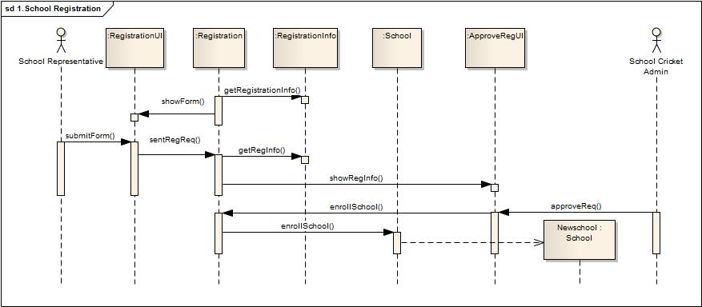

* 1. **School Cricket Tournament Arrange**

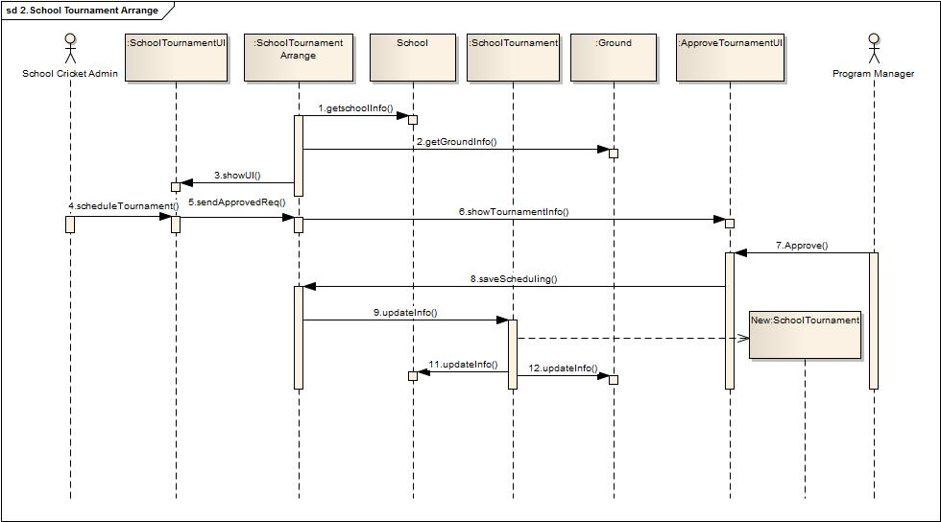

1. **Youth Cricket Management System:**
   1. **Arrange Youth Cricket Tournament**

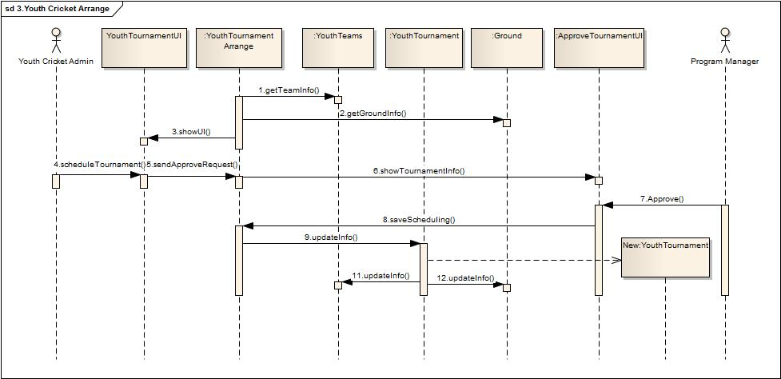

* 1. **Update Tournament Info**

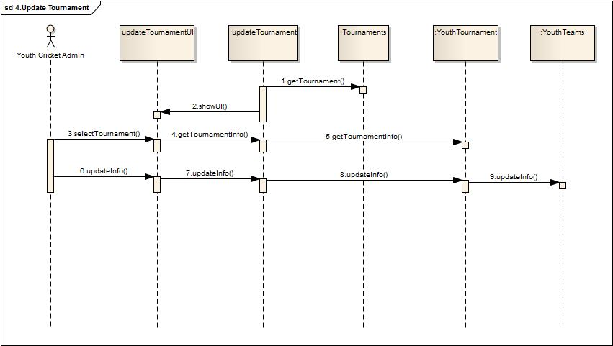

**3. Facility Management System:**

* 1. **Ask For Facility**

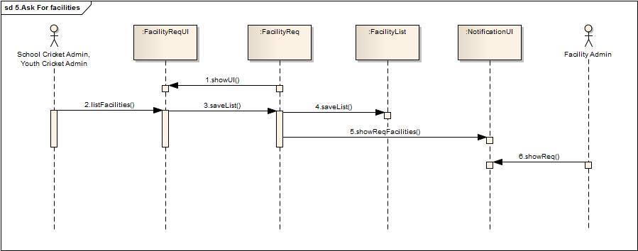

* 1. **Provide Facilities**

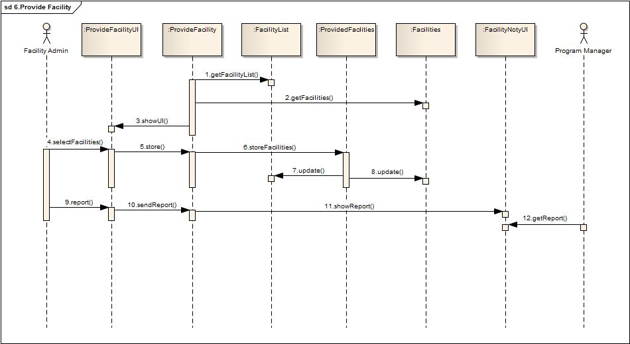

**4. Academy Operations Management System:**

**4.1: Maintain Academy Team**

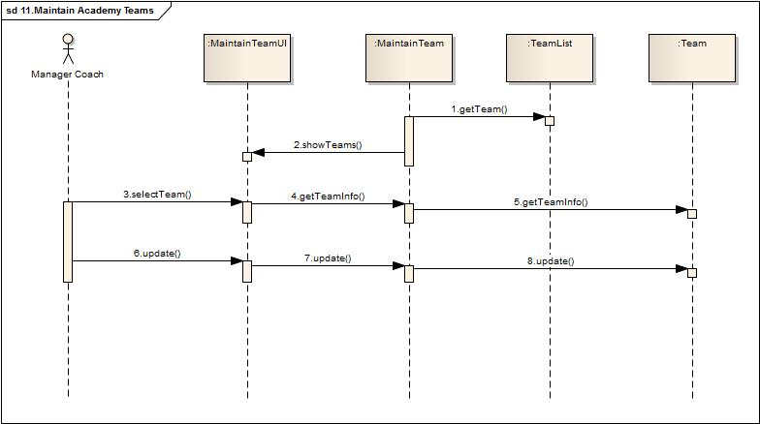

* 1. **Observe Players Lacking**

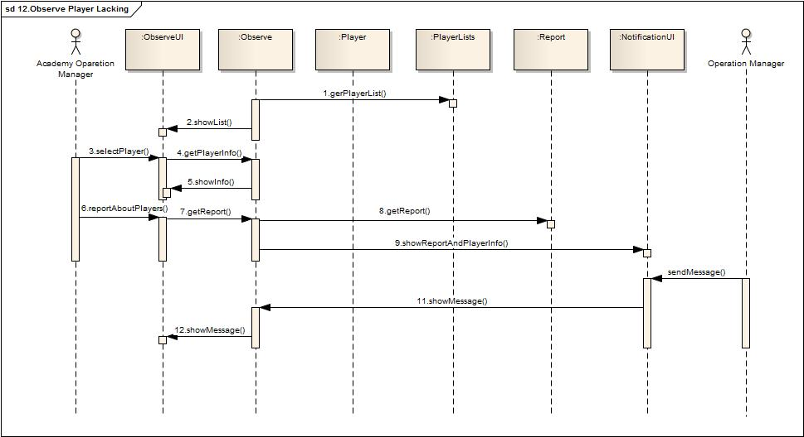

1. **Divisional Cricket Management System:**
   1. **Form District Teams**

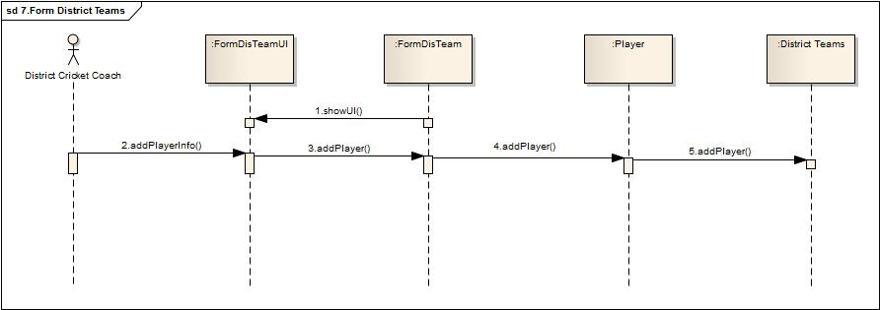

* 1. **Form Divisional Teams**

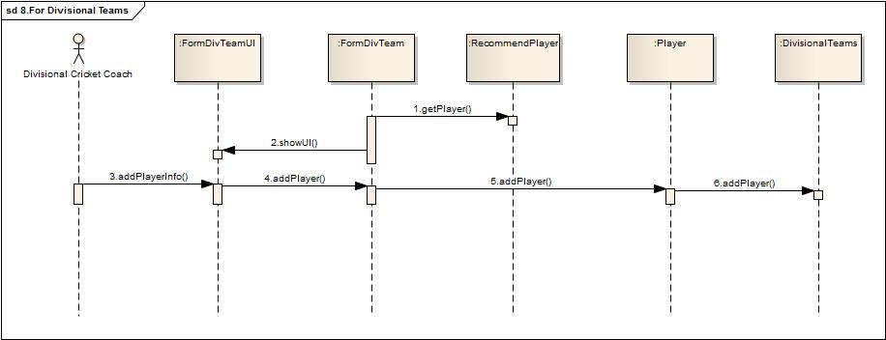

* 1. **Recommend Players**

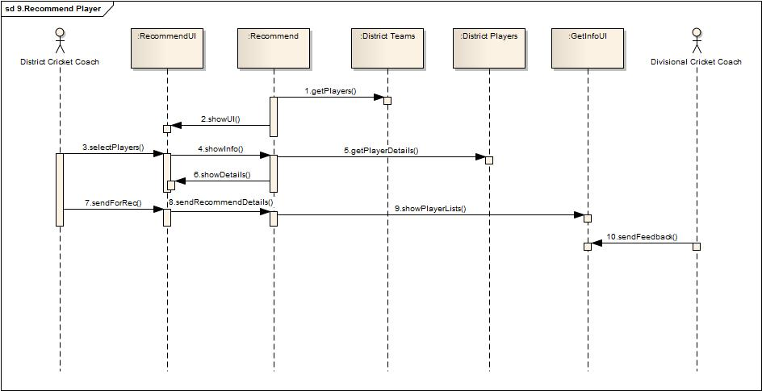

* 1. **Assign Coach**

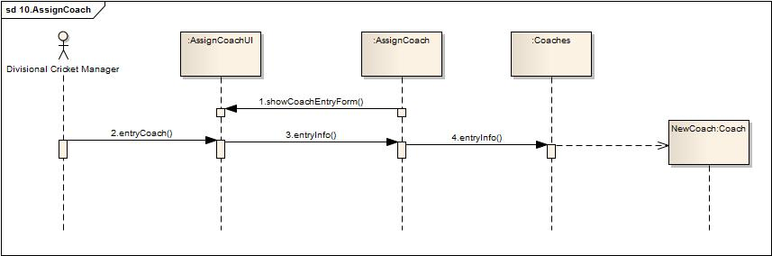

1. **Coach Management System:**

**6.1 Maintain Academy Coaches**

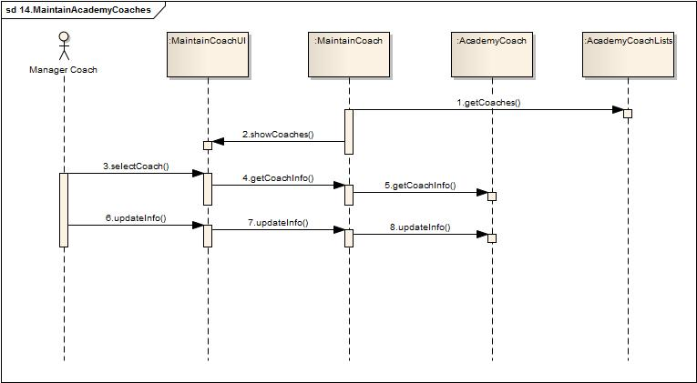

**6.2 Assign Head Coach**

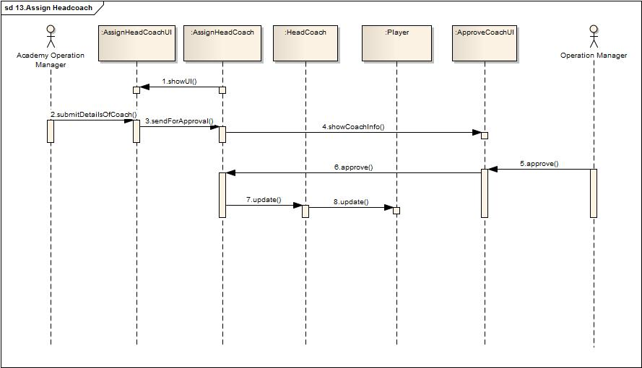

* 1. **Notify**

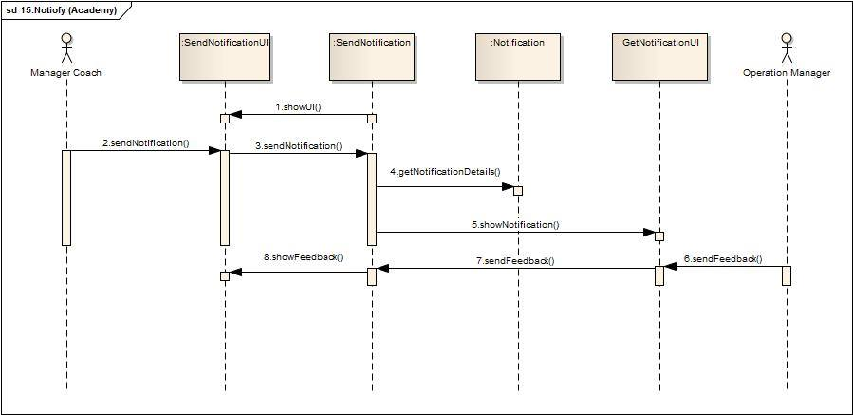

**7 Control Management System:**

* 1. **Observe All Subsystem**

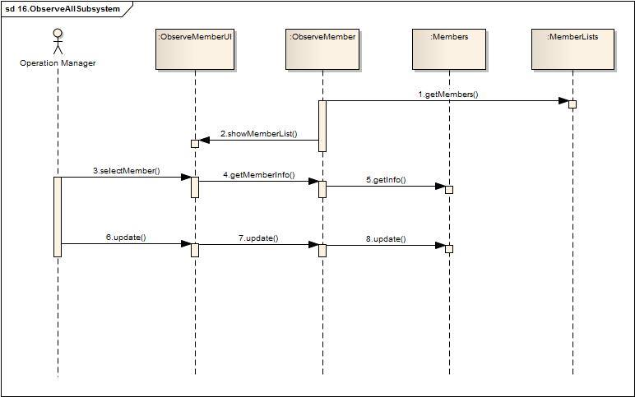

**Notify**

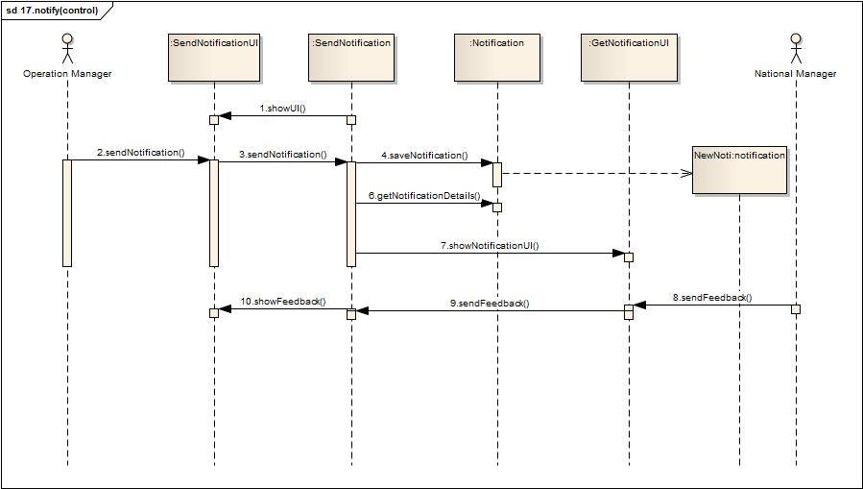

**State chart Diagrams:**

1. **RegistrationInfo Class:**

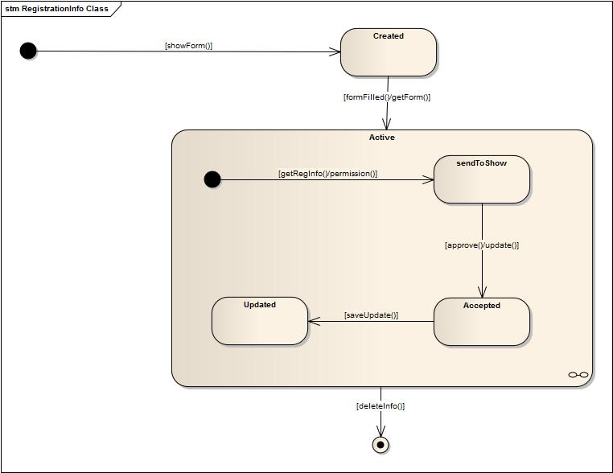

1. **School Class:**

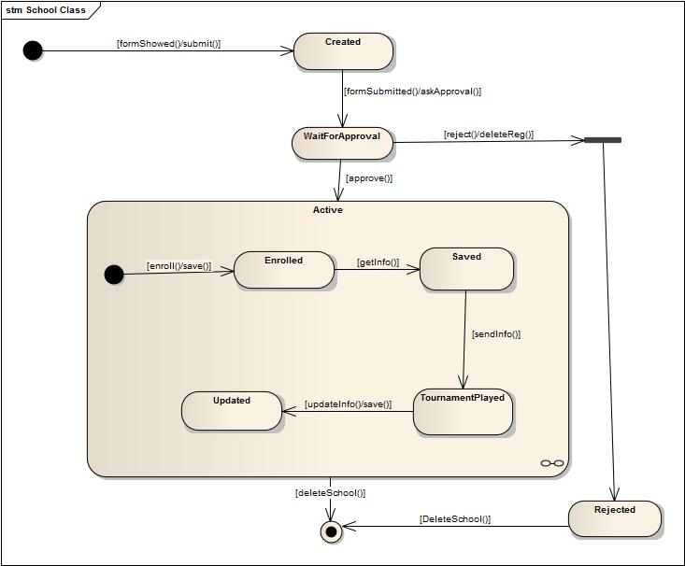

1. **SchoolTournament Class:**

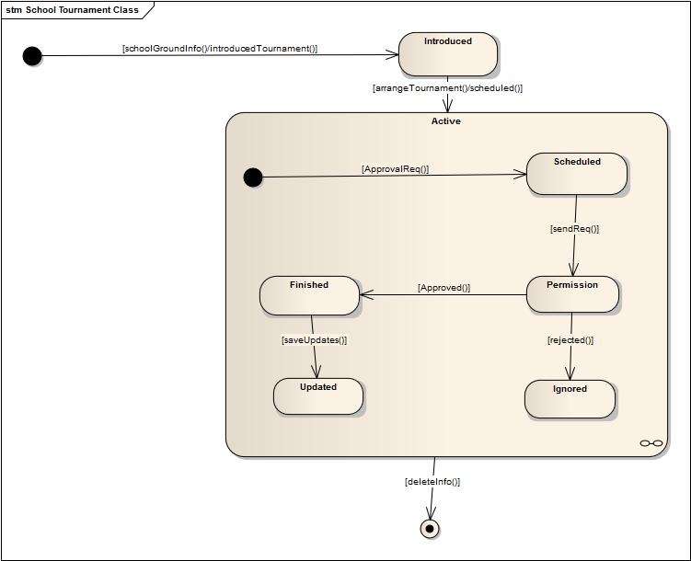

1. **YouthTeam Class:**

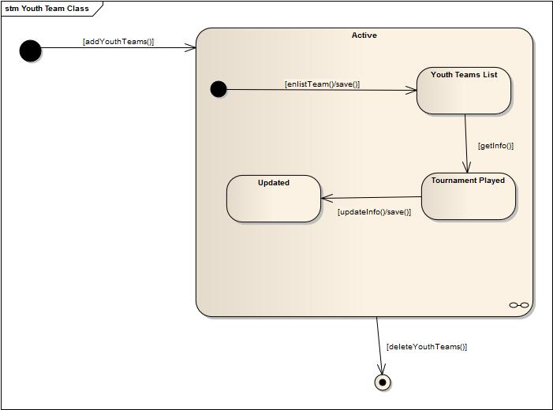

1. **Player Class:**

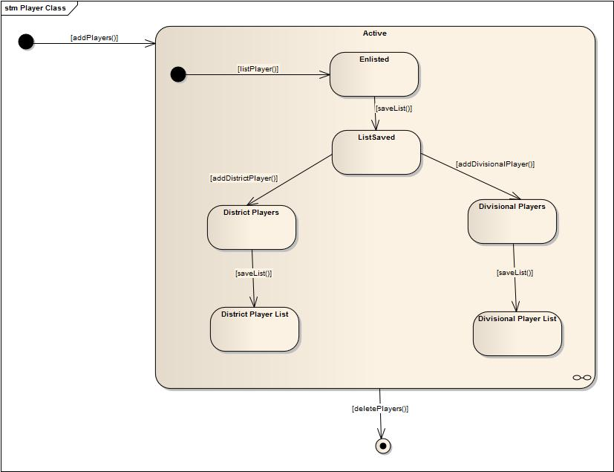

1. **Facilities Class:**

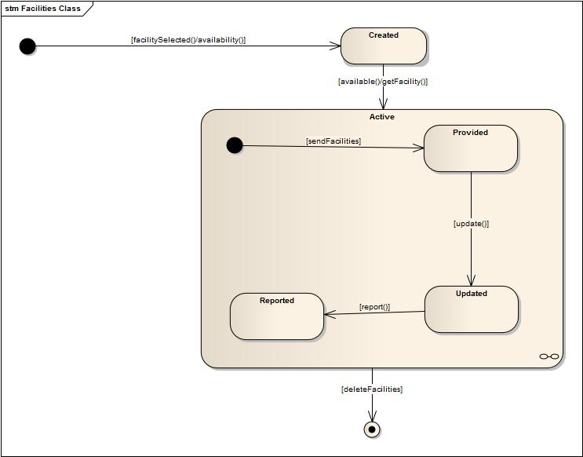

1. **FacilityLists Class:**

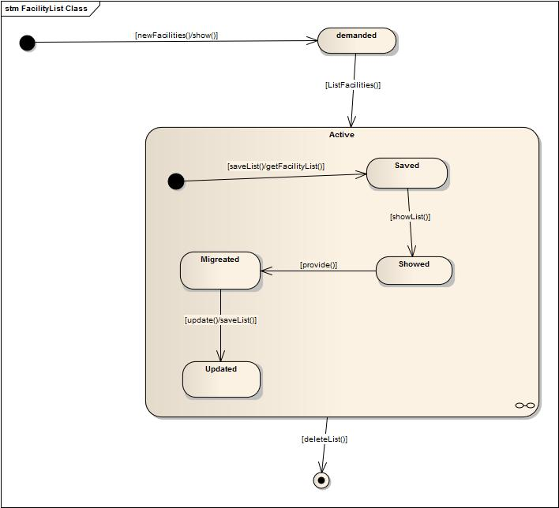

1. **DistrictPlayer Class:**

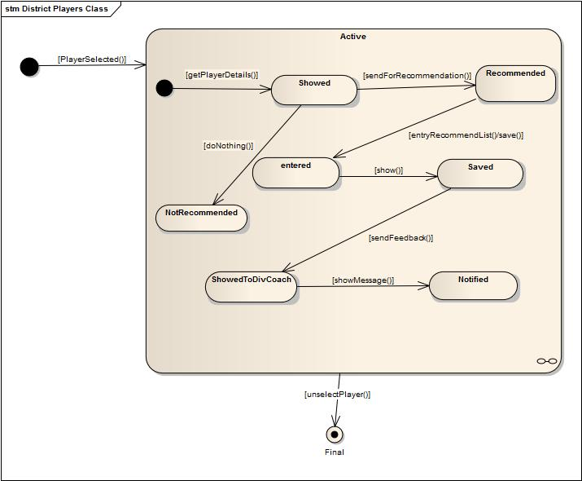

1. **AcademyPlayer Class:**

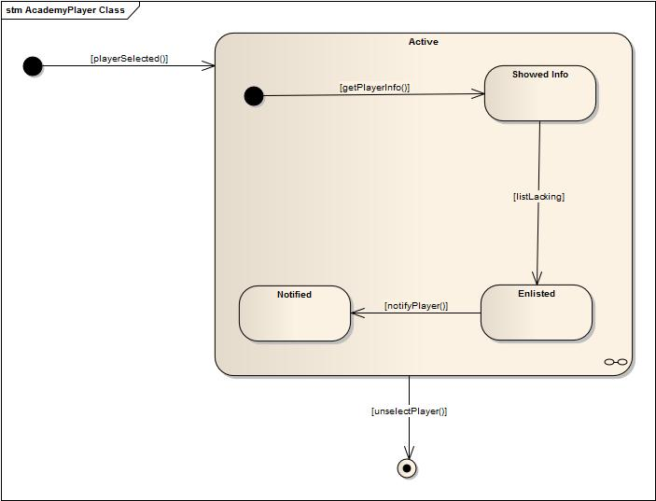

1. **Coach Class:**

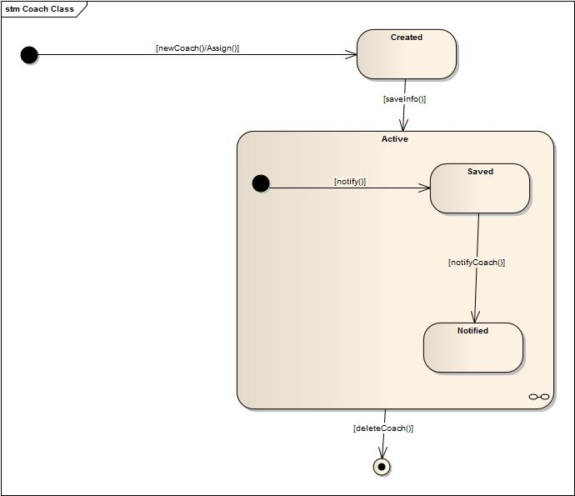

1. **AcademyCoach Class:**

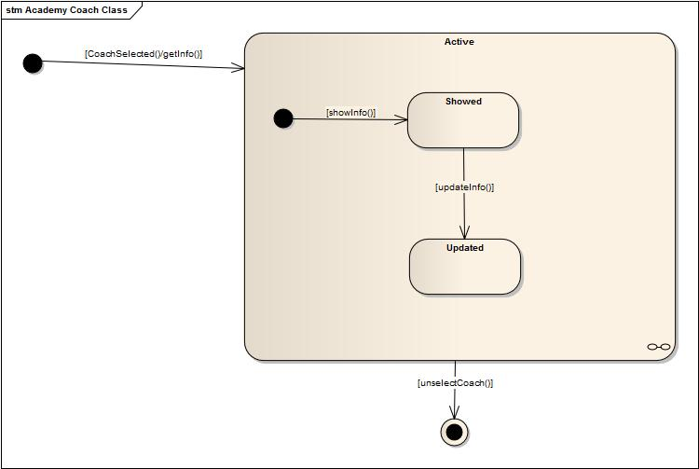

1. **Member Class:**

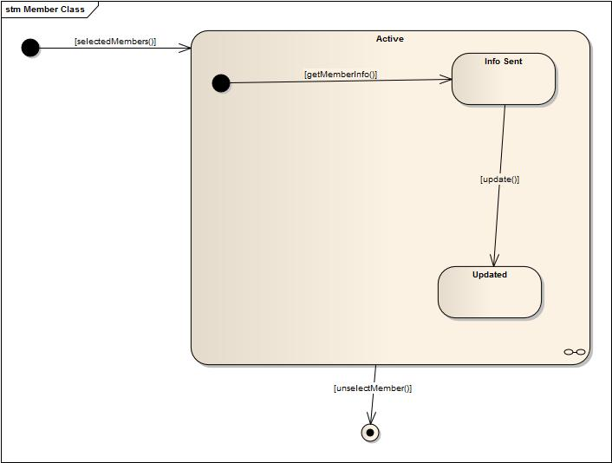

**Activity Diagrams:**

1. **School Cricket Management System:**
   1. **School Registration**



* 1. **School Cricket Tournament Arrange**



1. **Youth Cricket Management System:**
   1. **Arrange Youth Cricket Tournament**



* 1. **Update Tournament Info**



**3. Facility Management System:**

* 1. **Ask For Facility**



* 1. **Provide Facilities**



1. **Academy management system:**

**Observe Players Lacking**



1. **Divisional Cricket Management System:**
   1. **Form District Teams**



* 1. **Form Divisional Teams**
  2. **Recommend Players**
  3. **Assign Coach**



1. **Coach Management System:**
   1. **Maintain Academy Coaches**



* 1. **Assign Head Coach:**



1. **Control Management System:**
   1. **Observe All Subsystem**

